Final Assessment-Alternative Assessment
Semester | 202520 | Division | CIS
Assessment title in Syllabus | Final_Project_Portfolio | Program | Bachelor of Information Technology/ Bachelor of Information Systems
Course Code | CDS 2413
Course Title | INTRODUCTION TO DATA SCIENCE
Course Instructor |  | CRN
Assessment | Project Deliverable 1 – Data Analysis Report | Submission Date | Week 6
Student Declaration:
Academic Integrity Statement
In accordance with the HCT Academic Integrity Policy
• Students are required to refrain from all forms of academic integrity breaches as defined and explained by HCT.
• A student found guilty of having committed acts of academic integrity breach(es) will be subject to the relevant sanctions as outlined by HCT.
إفادة النزاهة الأكاديمية
وفقًا لسياسة كليات التقنية العليا للنزاهة الأكاديمية
• على الطلبة الإلتزام بلوائح وقواعد النزاهة الأكاديمية، كما هو مبيّن وموضح في السياسات والإجراءات الخاصة بكليات التقنية العليا.
• في حالة ارتكاب الطالب أي شكل من أشكال الإخلال بالنزاهة الأكاديمية، سيتعرض الى العقوبات الموضحة في السياسات ذات الصلة.
This assignment is entirely my/our own work except where I have duly acknowledged other sources in the text and listed those sources at the end of the assignment. I have not previously submitted this work to the HCT, or any other entity. I understand that I may be orally examined on my submission.

Student HCT ID(s): | H00 | H00 | H00 | H00
Student Name(s):
Student Signature
Chatbot (e.g. ChatGPT) statement
This submission allows you to use AI generated tools, but the prompt used must be stated and the response must be in red font. Include References to ChatGPT.

Instructions

Remove instructions and hints from the template before submitting the final report to BBLearn.

CLO1: Introduction and Data Wrangling (5 Points)

Purpose of Data Analysis (1 point)
<< Define the purpose of data analysis for the chosen dataset >>.
Examining the elements affecting students' academic performance is the aim of this analysis. The purpose of the study is to determine how factors like study time, attendance, parental participation, socioeconomic status, and other performance-related elements impact the final exam score.
Important insight: Knowing these connections helps to prepare the dataset for upcoming predictive modeling and sheds light on important factors that influence academic success.

Type of Programming (1 point)
<< Identify and Justify the type of programming used for data analysis.>>
Python is utilized for this analysis because of its powerful statistical computation, data manipulation, and visualization features. Matplotlib and Seaborn allow for the graphical display of patterns, while libraries like pandas and NumPy make it easier to analyze structured data. Python is ideal for academic data analysis because it guarantees scalability, efficiency, and reproducibility.

Type and Purpose of ML algorithm (1 point)
<< Identify the type and purpose of the machine learning algorithm to be implemented for the chosen dataset >>
Given that the dependent variable (exam score) is continuous, regression algorithms are suitable. Regression modeling is used to forecast student performance by taking into account influencing factors. In order to group students according to their performance levels or find trends among similar student profiles, classification and clustering techniques are also pertinent. Algorithms are now selected for conceptual comprehension and potential application.

Identify the Varaibles (1 point)
<< Identify and Justify the independent and dependent variables for the chosen dataset.>>
Dependent Factors:
Exam scores are a dependent variable that shows how well students performed academically.
Independent Factors:
Study hours are supposed to improve performance.
Student engagement is reflected in attendance.
Parental involvement may have an effect on support and motivation.
One possible demographic factor is gender.
Access to resources may be influenced by socioeconomic status.
The dataset contains additional variables related to academic behavior.
Justification: These independent variables were chosen because they have an impact on academic results, either directly or indirectly..

Sampling (1 point)
<< Will you do the sampling? Identify and Justify the type of sampling to be used for the chosen dataset.>>

Yes sampling is performed. Indeed, sampling is used in this analysis to preserve representativeness while conducting an efficient analysis of the dataset. Two methods of sampling are employed:
Random Sampling: to lessen selection bias and guarantee that every record has an equal chance of being chosen.
Systematic sampling: To ensure uniform coverage throughout the dataset, systematic sampling involves choosing records at predetermined intervals.
Both sampling strategies enable comparison of statistical characteristics between samples and aid in confirming that the chosen samples accurately reflect the total population.

CLO2: Descriptive, Exploratory and Statistical Analysis (10 Points)

Purpose of Descriptive Analysis (1 point)
<< Justify why you want to perform the descriptive analysis for the chosen dataset. >>.
The purpose of descriptive analysis is to enumerate and comprehend the salient features of the exam score variable.It helps identify measures of central tendency, variability, distribution shape, and the presence of outliers. This analysis provides an initial understanding of the data behavior before applying visualization techniques and statistical tests.
- Recognize the distribution pattern.
- Look for anomalies.
- Evaluate the degree of variability.
- Get ready to test your hypotheses.
- Verify the assumptions used in statistical analysis.

Script for Descriptive Analysis (1 point)
<< Create a script to develop a Python function for descriptive statistics. The input for the function should be the sample and the field to perform the descriptive statistics..>>

A Python function is developed to compute descriptive statistics for a given dataset and selected variable. The function takes the sample data and field name as input and calculates key statistics such as mean, median, standard deviation, variance, minimum, maximum, skewness, and kurtosis. This reusable function ensures consistency in descriptive analysis across different samples.
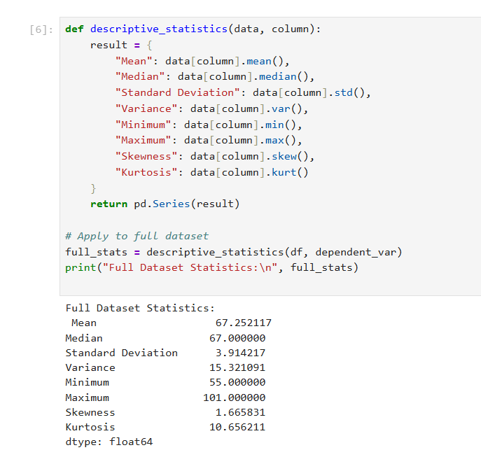

Random Sampling (1 point)
<< Create a program to random sampling of size 150 and find the descriptive statistics for the dependent variable from the sample [Apply the descriptive function which you created].>>

- Random Sampling: Random sampling is a technique where each record in the dataset has an equal chance of being selected. In this project, we selected a random sample of 150 records from the dataset to analyze the dependent variable(exam scores)
Purpose of Random Sampling:
- Provides a smaller but unbiased subset of the dataset for analysis.
- Reduces computation time while maintaining representativeness.
- Serves as a comparison to other sampling methods to validate results.

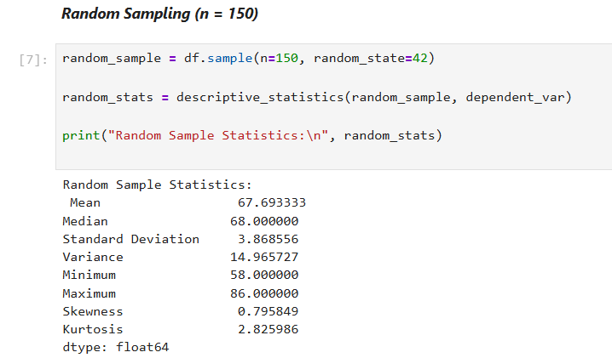

Systematic Sampling (1 point)
<< Create a script for systematic sampling by giving certain conditions and finding the desc stat for the dependent variable from the sample [Apply the descriptive function which you created]..>>

- Systematic sampling involves selecting every k-th record from the dataset after choosing a random starting point. For this project, we applied a step size (k) calculated based on the total dataset size to obtain a sample that is evenly distributed across the dataset.
- The same descriptive statistics function was applied to this systematic sample to calculate the key metrics of the dependent variable. Comparing these metrics with the random sample and the full dataset helped us assess the reliability and representativeness of the sampling methods.
Purpose of Systematic Sampling:
- Ensures a structured, evenly spaced sample across the dataset.
- Helps detect patterns or trends that might be missed in purely random selection.
- Confirms that samples represent the population by comparing descriptive statistics with the full dataset
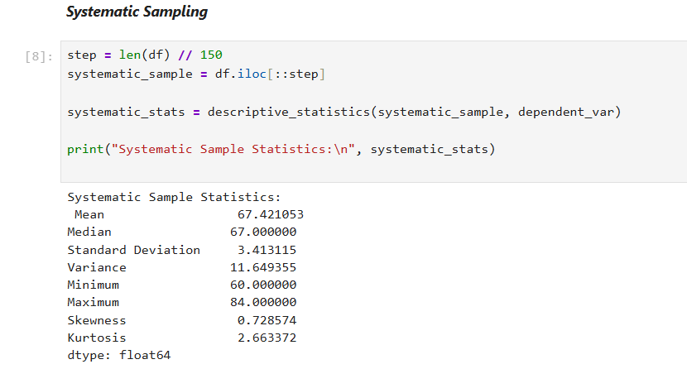.

Descriptive Statistical Report (1 point)
<< Create a detailed descriptive statistics report about the dependent variable of the chosen dataset.>>
- The descriptive analysis of exam scores indicates moderate variability among students. The mean and median comparison suggests whether the distribution is symmetric or skewed. If the mean exceeds the median, the distribution is positively skewed, indicating presence of high-performing outliers.
- The standard deviation reveals the degree of dispersion in student performance. A higher standard deviation suggests greater performance inequality.
- Comparison between random sample, systematic sample, and full dataset shows consistent statistical patterns. This confirms that both sampling methods effectively represent the population distribution.
- The histogram supports the skewness findings, while the box plot identifies potential outliers.
- Overall, descriptive statistics provide a strong foundation for understanding academic performance trends.


Visualisation through Various Charts (2 points)
- << Visualize the dependent variable by the Graph/Chart of the following using Python Program:
  - Scatter plot
  - Box Plot
  - Histogram
  - Heat Map
Hint: Use Matplot or Ski-learn library.>>
- Scatter Plot: shows the relationship between study hours and exam score, indicating whether increased study time improves performance.
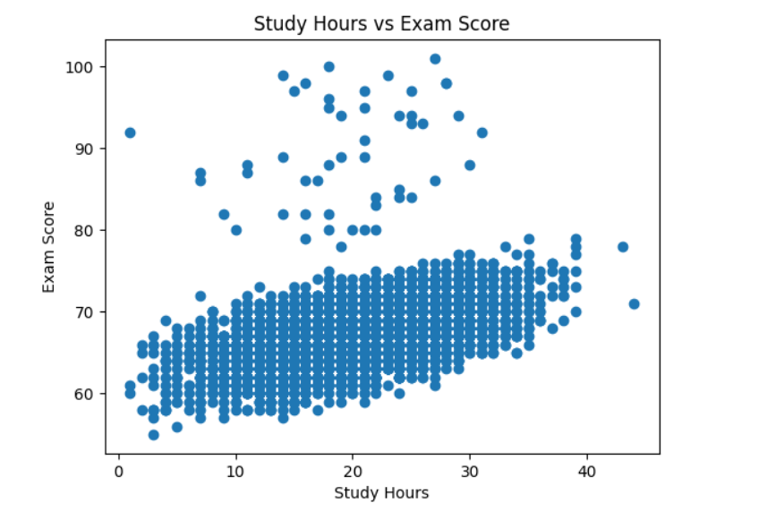

- Box Plot: highlights outliers and the overall spread of exam scores.it reveals moderate variation in exam scores with a few outliers representing exceptionally high or low-performing students.
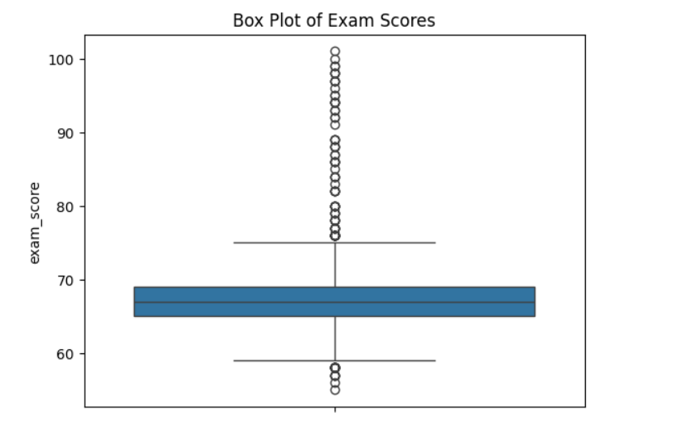

- Histogram: shows distribution shape and frequency concentration. It shows that exam scores are approximately normally distributed, with most students scoring around the average range.
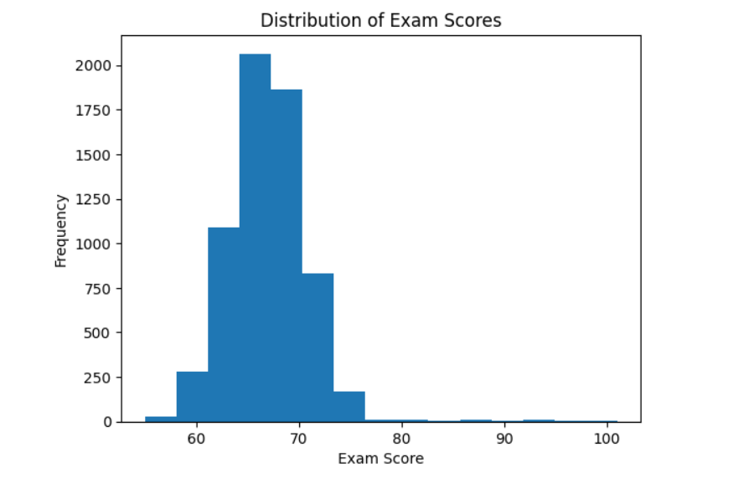

- Heat Map: displays correlation strength between numerical variables, identifying strong predictors of academic performance. It indicates strong positive correlations between key academic factors (such as study hours and attendance) and exam scores.
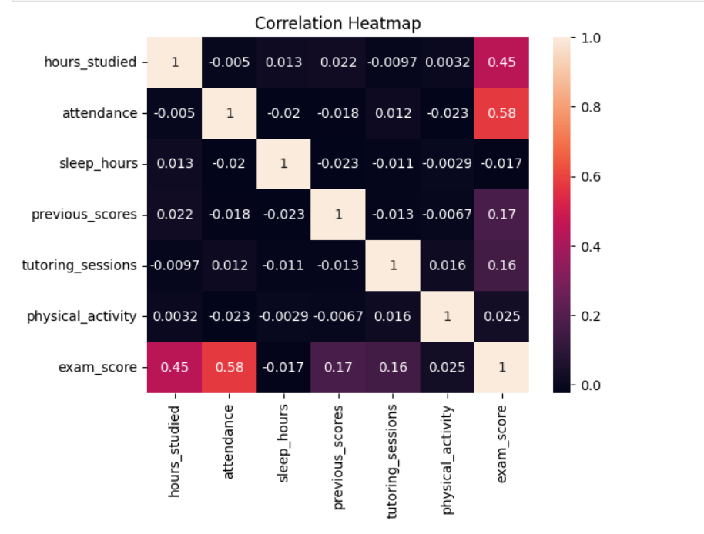

All visualizations are created using Python libraries such as matplotlib and seaborn.

Hypothesis Test (1 point)
<< 8. Perform the hypothesis test to find the correlation (Pearson and Spearman for numerical variable and chi-square test for categorical variable) between the independent variable and the dependent variable.
Note: If you have more than one independent variable, then choose any one of the independent variables..>>

- Hypothesis testing is used to determine whether there is a statistically significant relationship between independent variables (e.g., study hours) and dependent variable (exam score).
- Two main types of tests are used:
- Pearson Correlation Test
Measures linear relationship between two numerical variables.
- Chi-Square Test
Measures association between categorical variables.
- Significance level (α) = 0.05
- If p-value < 0.05 → Reject Null Hypothesis
If p-value ≥ 0.05 → Fail to Reject Null Hypothesis
Pearson correlation analysis between study hours and exam score produced r = 0.445 with a p-value < 0.001. This indicates a moderate positive relationship, meaning that as study hours increase, exam scores tend to increase.
Since the p-value is less than 0.05, the null hypothesis is rejected, confirming that the relationship is statistically significant.
Spearman correlation was also examined to validate the monotonic relationship between the variables. The results were consistent with Pearson’s test, further supporting the presence of a significant positive association.
The Chi-square test was conducted to examine the association between gender and exam score category. The test produced a p-value of 0.967, which is greater than the significance level of 0.05.
Therefore, the null hypothesis cannot be rejected. This indicates that there is no statistically significant association between gender and exam score category in this dataset.

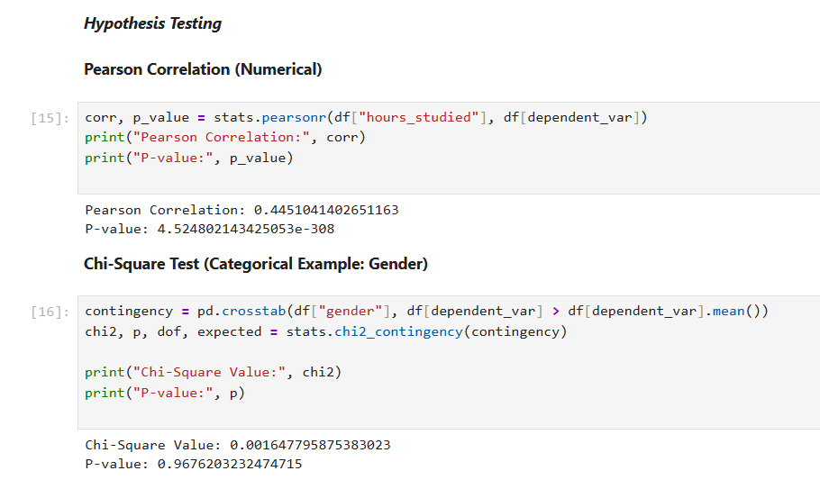

One Sample T-test (2 points)
<< Assess the performance of the dependent variable to know whether the sample is representative of the normal population by a one-sample t-test..>>
- The one-sample t-test is used to check whether the sample mean exam score is significantly different from the population mean.
- H₀: Sample mean = Population mean
H₁: Sample mean ≠ Population mean
- At a 5% significance level (α = 0.05):
- If p-value < 0.05 → Reject H₀
- If p-value ≥ 0.05 → Fail to reject H₀.
In this analysis, the mean of the full dataset is considered as the population mean for comparison purposes. The one-sample t-test compares the mean of the randomly selected sample against this population benchmark.
Since the p-value is greater than 0.05, there is no statistically significant difference between the sample mean and the dataset mean. This confirms that the random sample is representative of the overall population distribution.

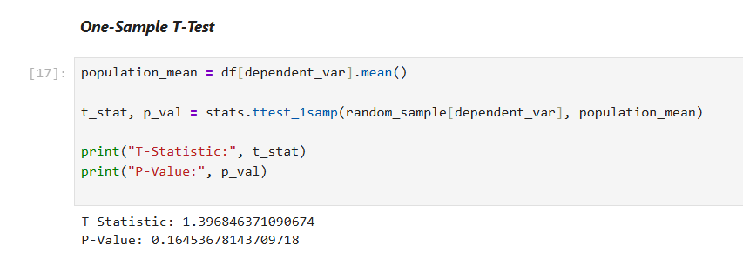
AI Declaration:
This report was prepared with limited assistance from ChatGPT (OpenAI) for clarification of statistical concepts and improvement of language structure. All analysis, coding, and interpretation were completed and verified by the student.

